Homework 3

# Reference

* For data loading: <https://stackoverflow.com/questions/32113942/importing-cifar-10-data-set-to-r>

# Database

CIFAR-10

# Library

* Grid: image visualization

# Part 1

## Graph

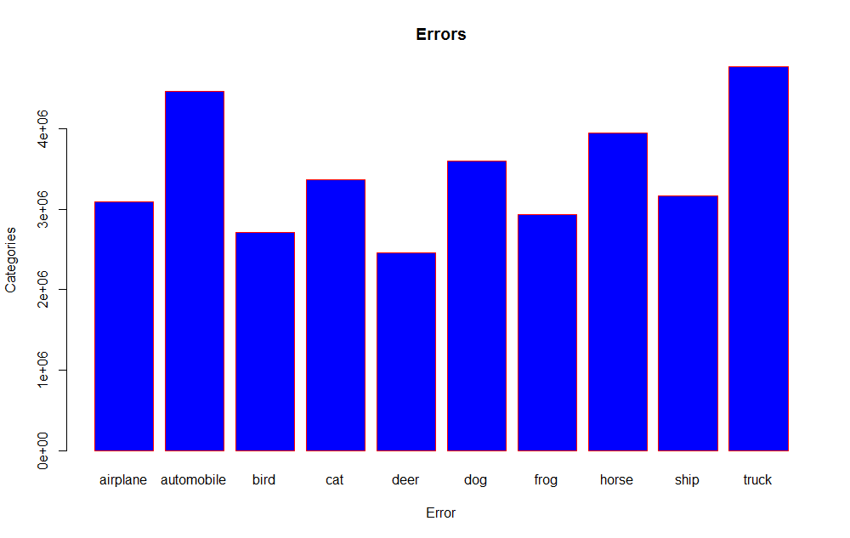

# Part 2

## Distance Matrix

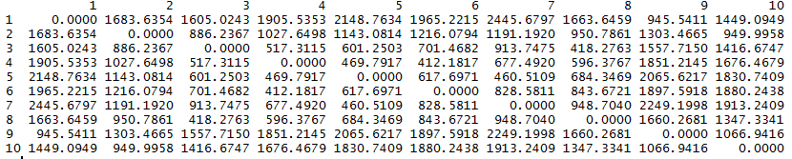

## Graph

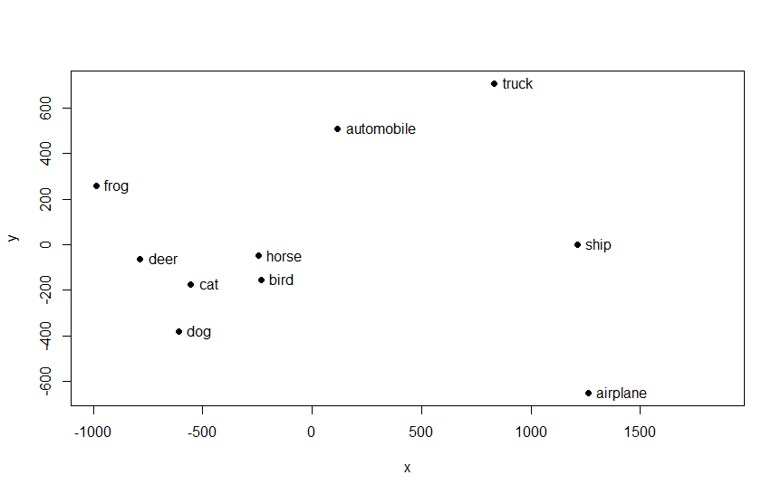

# Part 3

## Distance Matrix

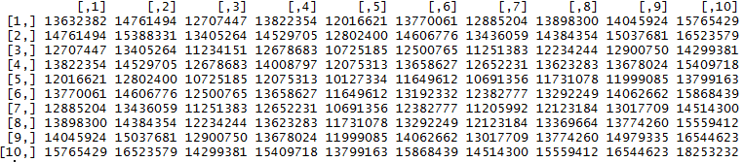

# Graph

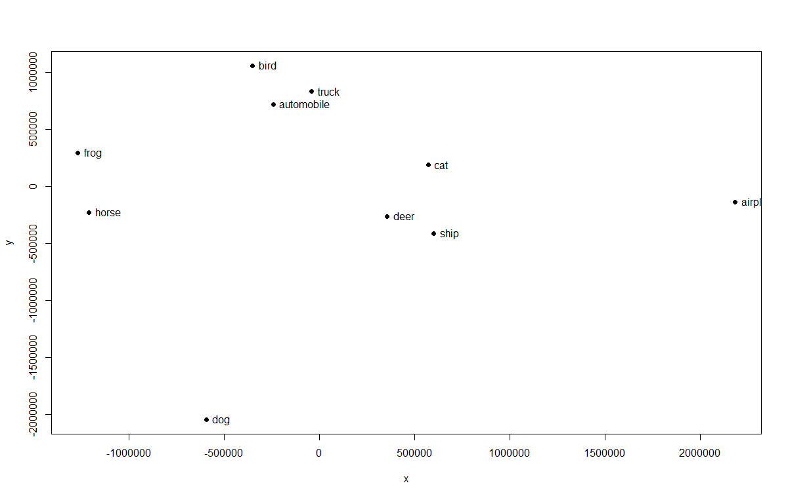

## Why are they different?

In part 3, distance matrix is defined by how closely can a class be represented by eigen vectors of other class. It can be seen that truck and automobile classes are closer in this graph, as truck’s eigen vectors can closely represent automobile class.